EXPERIMENT 1

AIM
To design an interactive diagram using Figma illustrating the components of a basic cellular system.

PROCEDURE
- Open Figma and create a new design file.
- Create shapes and labels to represent the main components of a cellular system, such as the Mobile Station (MS), Base Transceiver Station (BTS), Base Station Controller (BSC), Mobile Switching Centre (MSC), and Public Switched Telephone Network (PSTN).
- Arrange the components in a logical sequence and connect them using lines and arrows to show communication flow.
- Add colors, icons, and text labels to make the diagram clear and attractive.
- Use Figma's prototyping features to add interactive elements, such as clickable components and navigation between frames.
- Preview the prototype to verify that all interactive elements work correctly.
DESIGN
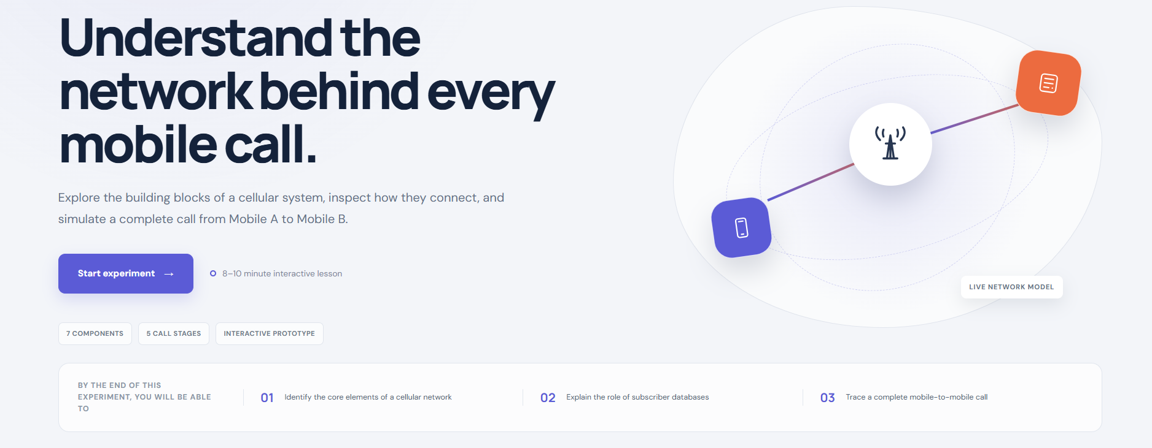
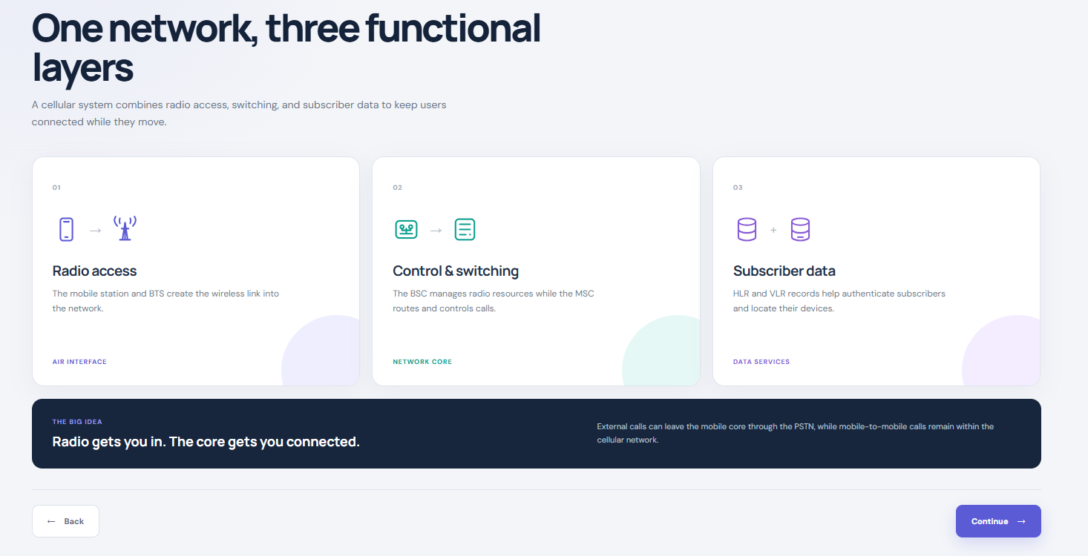
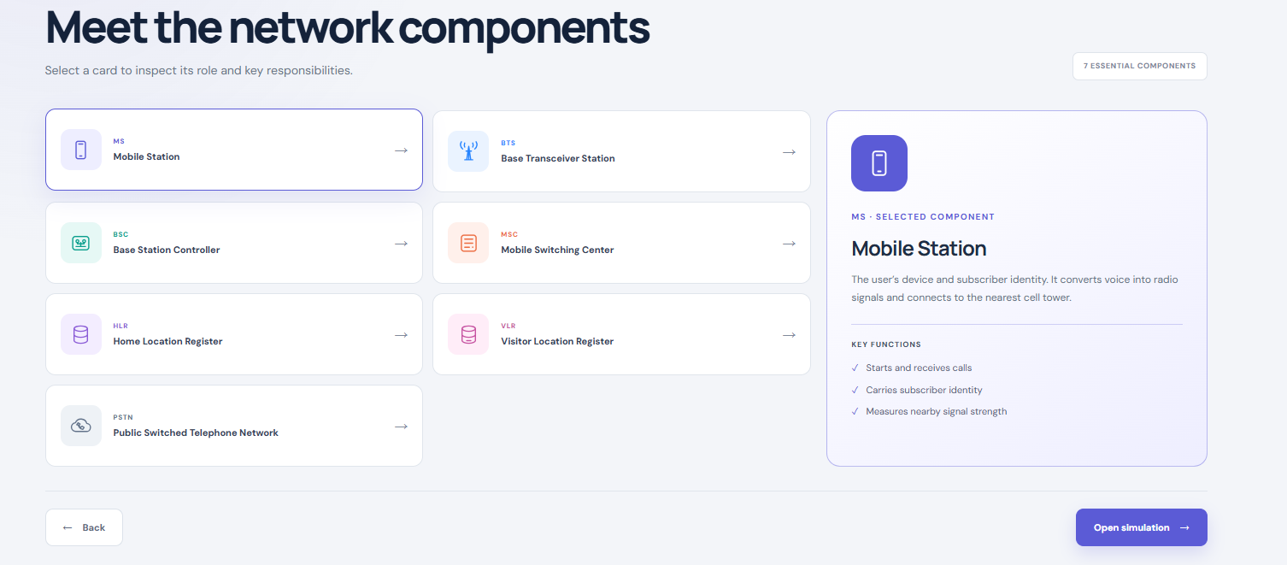
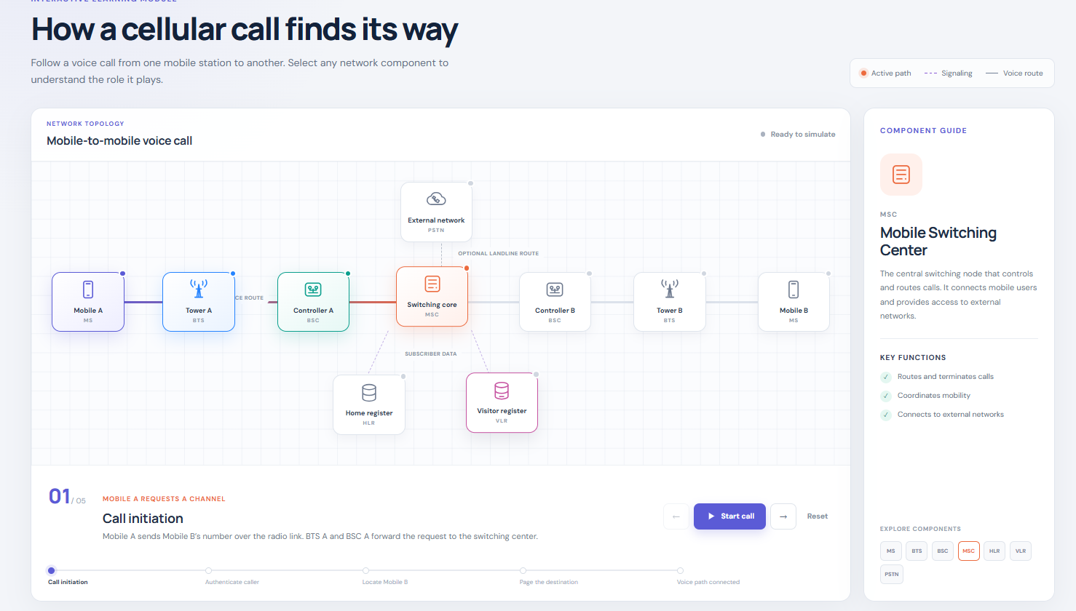

PROTOTYPE


RESULT
Thus, an interactive diagram illustrating the components of a basic cellular system was designed using Figma, showing the major components and their communication flow.

